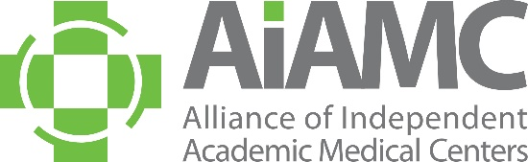

ALLIANCE OF INDEPENDENT
ACADEMIC MEDICAL CENTERS
2023 Annual Meeting
Call for Breakout Session Proposals

All AIAMC members are invited to submit a proposal for a breakout session at the 2023 AIAMC Annual Meeting, to be held March 23rd – 25th at the Loews Vanderbilt Hotel in Nashville. We encourage you to share this call with AIAMC-member colleagues, especially your residents who may not typically receive these announcements.

Breakout sessions must have a hands-on workshop format that provides practical tips on applying the principles presented in the plenary sessions and will be 75 minutes in length. Proposals are due no later than September 15, 2022, and all submitting presenters will be notified of the selection committee's decision in mid -October.

These breakouts will feature AIAMC members who have good stories to share. Session content should support the meeting theme of Creating Culture as follows:

- Generational Differences of Well-Being
- The Great Resignation
- Social and Moral Determinants of Health
- Innovative Approaches to Medical Education

Breakout sessions should have a hands-on workshop approach and be highly interactive. Prior to submitting your proposal, please review the example provided of a prior breakout session proposal that was accepted by the selection committee. We hope this exemplar will be helpful to you as you develop your institution’s proposal(s).

A selection committee – made up of AIAMC members serving on the 2023 Annual Meeting Planning Committee – will determine which proposals are accepted. Submitters will be notified of the committee’s selections in mid-October. All accepted presenters are required to register for the conference. In accordance with AIAMC policy, all registration fees and travel expenses will be the responsibility of the presenter’s home institution. Submitting a proposal is a commitment that, if the proposal is accepted, all proposed presenters will attend the 2023 Annual Meeting and conduct the session at the time assigned.

We encourage you to submit a proposal and look forward to seeing you at the meeting!

